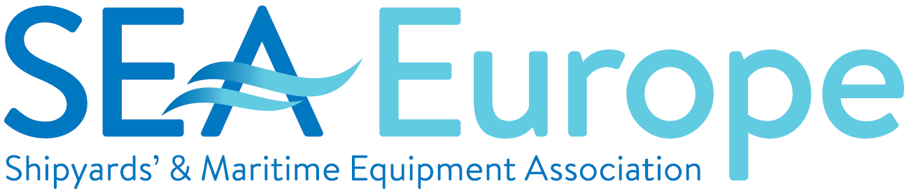

LASHFIRE CONFERENCE ON FIRE SAFETY AT SEA
15 December 2021

SEA Europe intevention
Setting the scene - Setting the scene from a regulatory and industry perspective

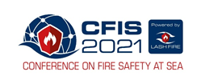

First of all, I want to thank the colleagues in the LASH FIRE consortium who have organised this event and for having invited me for you today to set the scene with EMSA and Interferry. My name is Benoit Loicq, representing SEA Europe, the association of shipyards and maritime equipment manufacturers in the EU, Norway and Turkey.

In the project, the leading role of SEA Europe consists of establishing and coordinating the MAAG, the Maritime Authorities Advisory Group, consisting of representatives of Flag states Authorities and EMSA. The role of the MAAG is to advise on future regulations and legislations and their implementation.
The second Advisory Group of LASH FIRE is the MOAG, the Maritime Operators Advisory Group, which is coordinated by INTERFERRY.

LASH FIRE builds on the outcome of FIRESAFE I &II studies and aims to provide a recognized technical basis for the revision of international IMO regulations, which greatly enhances fire prevention and ensures management of fires on ro-ro ships without recourse to external intervention.

This is done by developing and demonstrating operational and design solutions which strengthen the fire protection of ro-ro ships in all stages of a fire, and which address current and future challenges, including regulatory issues.

The LASH FIRE project provides valuable insight into the different steps of fire propagation from ignition, prevention, detection, containment and extinguishing. Also operational issues play an important role in reducing the risk of fires and its consequences on Ro-Ro Passenger Ships. The project provides better understanding of operators procedures in this respect.

At the beginning of the LASH FIRE project, twenty specific challenges have been identified, which are being addressed by new solutions developed and demonstrated with regards to performance and ship integration feasibility by system suppliers, researchers, ship owners and shipyards. Also, what become very obvious to be dealt with in the context of LASH FIRE is coming from the increasing transport of Alternative Power Vehicles and the associated risk of fire.

Finally, all gained knowledge in the different work packages will help to design better ships with respect to fire safety. This in a more holistic view but also in the sense of the individual performance of e.g. fire detection- and extinguishing systems, but also adressing the environmental impact of some fire extinguisment technologies.

We also expect that scientifically matured proposals for IMO rule updates will help to prevent many of the - in some cases - catastrophic fires on Ro-Ro Passenger Ships in the past. In this respect I would warmly recommend you to follow the panel debate this afternoon as we will get more insight on how the LASH FIRE outcome could be implemented more quickly into IMO international and national rules and regulations, if agreed.

Thank you very much for your attention.

