Project acronym: LASH FIRE
Project full title: Legislative Assessment for Safety Hazard of Fire and Innovations in Ro-ro ship Environment
Grant Agreement No: 814975
Coordinator: RISE Research Institutes of Sweden

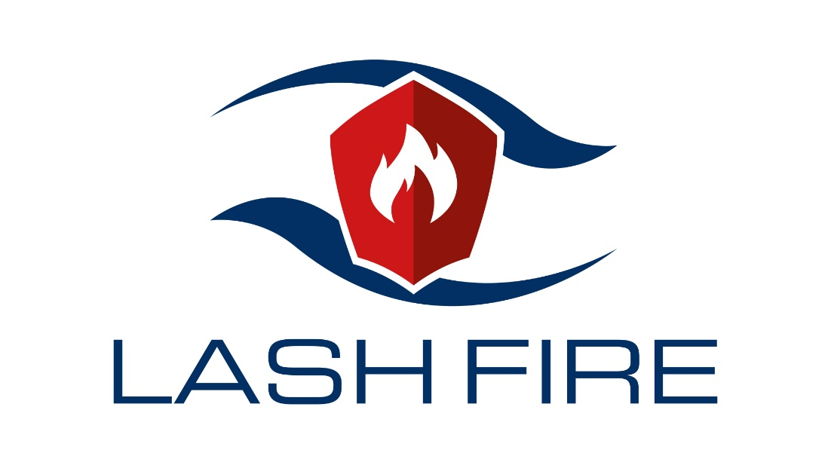

Deliverable D03.1
Website published, initial version
February 2020

Dissemination level: Public
Abstract
As part of LASH FIRE’s work package 3 (Cooperation and Communication), a website has been created to be used as part of the dissemination of the LASH FIRE project. This document provides insight and understanding of the website and its development process, including choices made regarding design and structure. The document also contains information regarding which specific goals and deliverables this deliverable D03.1 relates to in LASH FIRE and enables the reader to get an overall understanding of the impact of this delivery.
An updated project website (version 2.0) was published on January 13th, 2020. It will serve as a draft to the final version which will also include the project video and much more information from the LASH FIRE project, such as publications, additional press releases and other general dissemination.

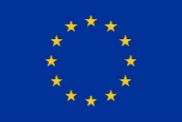
This project has received funding from the European Union’s Horizon 2020 research and innovation programme under grant agreement No 814975

The information contained in this deliverable reflects only the view(s) of the author(s). The Agency (INEA) is not responsible for any use that may be made of the information it contains.

The information contained in this report is subject to change without notice and should not be construed as a commitment by any members of the LASH FIRE consortium. In the event of any software or algorithms being described in this report, the LASH FIRE consortium assumes no responsibility for the use or inability to use any of its software or algorithms. The information is provided without any warranty of any kind and the LASH FIRE consortium expressly disclaims all implied warranties, including but not limited to the implied warranties of merchantability and fitness for a particular use.

© COPYRIGHT 2019 The LASH FIRE Consortium

This document may not be copied, reproduced, or modified in whole or in part for any purpose without written permission from the LASH FIRE consortium. In addition, to such written permission to copy, acknowledgement of the authors of the document and all applicable portions of the copyright notice must be clearly referenced. All rights reserved.
Document data
Document Title: | D03.1 – Project website published, initial version
Work Package: | WP3 – Cooperation and Communication
Related Task(s): | T03.05
Dissemination level: | Public
Deliverable type: | DEC
Lead beneficiary: | 01 – RISE
Responsible author: | Alexander Hertzberg
Co-authors:
Date of delivery: | 2020-02-28
References:
Approved by | Sabine Schilling on 2020-01-21 | Benoît Loicq on 2020-02-17 | Franz Evegren on 2020-02-26

Involved partners
No. | Short name | Full name of Partner | Name and contact info of persons involved
01 | RISE | RISE Research Institutes of Sweden | Alexander Hertzberg, alexander.hertzberg@ri.se

Document history
Version | Date | Prepared by | Description
01 | 2019-10-23 | RISE | Draft for review of structure
02 | 2020-01-14 | RISE | Final draft for review
03 | 2020-02-27 | RISE | Final and approved version

Content
1 Executive summary 4
1.1 Problem definition 4
1.2 Technical approach 4
1.3 Results and achievements 4
1.4 Contribution to LASH FIRE objectives 4
1.5 Exploitation and implementation 4
2 List of symbols and abbreviations 5
3 Introduction 6
4 LASHFIRE.eu 7
4.1 Structure 7
4.1.1 WordPress 7
4.1.2 The Grid-layout 7
4.2 Design 7
4.2.1 HTML, CSS and JS 7
4.2.2 Graphic profile 7
4.2.3 Images 7
4.3 Version by version 8
4.3.1 LASHFIRE 1.0 8
4.3.2 LASHFIRE 2.0 9
5 Conclusion 11
6 Indexes 12
6.1 Index of figures 12

Executive summary

Problem definition
In order to maximize the potential dissemination of LASH FIRE, a project website is needed to inform about the project. This creates an opportunity but it can also be a challenge, as a website requires technical knowledge as well as communicative competence, not to mention collaborative ability.

Technical approach
The web is no longer one thing only but a vast ocean of opportunities and challenges. This is particularly true when it comes to websites today, as the biggest challenge nowadays is the variety of devices with internet access. A user can visit a website using their computer with a big screen or a small cell phone which impacts the viewing experience. Thus, a website has to be “mobile-friendly” or responsive nowadays, meaning the layout adjusts based on the device of the user. The technical approach of this delivery has been to enable as many persons as possible to access the content of the website, no matter the device used, while also making maintenance easy.

Results and achievements
A first version of the project website was published in October 2019 and was used as a landing page in order to support initial dissemination of the LASH FIRE project. In January 2020, a second version of the website was published which included additional information regarding the project and its partners, not to mention a general improvement of the graphic design.

Contribution to LASH FIRE objectives
Deliverable D03.1 is one of the cornerstones of work package 3, as dissemination today requires digital communication channels and therefore a website. The work in D03.1 primarily relates to the WP03 milestone “Established initial communication kit” (MS4). Specifically, this delivery concerns task T03.5: “Dissemination of Project Results to European Citizens, Policy and the Maritime Community”.
Based on the objectives in the Grant Agreement, D03.1 also concerns several parts of Article 29 “DISSEMINATION OF RESULTS – OPEN ACCESS – VISIBILITY OF EU FUNDING” and Article 38 “PROMOTING THE ACTION – VISIBILITY OF EU FUNDING”.
Furthermore, D03.1 relates to article 39.2 “Processing of personal data by the beneficiaries” as digital tracking is required to gather statistics regarding the number of site visitors etc., which is important for reporting as well as for strategic communication.

Exploitation and implementation
The website can be used by consortium members to share the latest news from the project but also enables the chance to show the overall structure of LASH FIRE to specific stakeholders and the general public. By using WordPress CMS, several members of WP03 can access the website and publish news, enabling quicker dissemination efforts and deeper collaboration within the WP.

List of symbols and abbreviations

HTML Hypertext Markup Language
CSS Cascade Style Sheets
JS JavaScript
CMS Content Management System

Introduction
Main author of the chapter: Alexander Hertzberg, RISE
Establishment of the LASH FIRE project website is part of the WP03 task T03.5. This chapter introduces the complete task T03.5, which includes general dissemination work which relates to the project website.
According to the description of work in the Grant Agreement:
“Task T03.5: Dissemination of Project Results to European Citizens, Policy and the Maritime Community (CMT, MAG, RISE, INF, SEA)
General dissemination on project developments and outcomes will be made continuously by a variety of measures, including publications, scientific papers, conference/workshop presentations and by providing specific dissemination material related to target groups, specified in more detail in section 2.2 Measures to maximize impact. A Data Management Plan (DMP) for providing open access to the research data will be developed at an early stage of the project and introduced in Deliverable D3.3. Partners will share the work according to their competences and network:
• Target Group “Shipbuilding and Equipment” – SEA supported by CMT
• Target Group “Shipping and Ship Operation” – INF supported by MAG (in close connection to MOAG)
• Target Group “General Public” – CMT supported by MAG
• Target Group “Policy” – MAG supported by RISE
• Target Group “Research and Academia” – RISE
Communication and interaction with target groups will primarily be organized using existing platforms, events or working groups, e.g. of the European Associations, such as WATERBORNE, SEA Europe, ECSA, ECMAR or INTERFERRY. A general dissemination and communication profile will be set up by CMT, to be used as template for all project communications. The task also includes:
• Organization of two public conferences, at mid-term and towards the end of the project, preferably jointly with other related projects or conferences, led by CMT and MAG, with the support from SEA and RISE.
• Establishment and maintenance of the project website and production of a project video (RISE)
• Production of two project brochures, one at the initiation of the project and one final (CMT).
• Development and update of the exploitation plan of the project, managed by MAG with support from SEA.
The objective of this task is to initiate, facilitate, monitor and report dissemination activities and to elaborate the exploitation plan, relying on the technical input from all partners and work packages. A comprehensive process will be established to achieve this goal, as described in detail in 2.2 Measures to maximize impact.”

LASHFIRE.eu
Main author of the chapter: Alexander Hertzberg, RISE
In this chapter, an overview of the project website is presented. By dividing it into three main pillars, structure, design and version by version, the idea is to include the process and what lead to several of the decisions made leading up to the current (initial) version of the LASH FIRE project website.

Structure

WordPress
Due to several reasons, a decision was made to use the popular platform CMS WordPress for the LASH FIRE website. One of the advantages is that several people in the project can access and edit the content of the project website without having to learn web design because it is user-friendly even for beginners. WordPress also enables the use of so called “plugins” which makes it possible for the project to take advantage of ready-to-use web solutions without any costs or for a very low fee.

The Grid-layout
As the use of internet has moved from computer screens to smart phones and tablets, web design has become an art in adjustment as the same content needs to be viewable in many different formats. One of the solutions to this is the grid layout which makes the simile of web design and assembling boxes, a reality. The layout enables the size of any box to be responsive to the format of the device, i.e. if you look at the website on your phone, boxes will line up vertically while on a bigger screen they will instead stand side by side due to greater spacing opportunities.

Design

HTML, CSS and JS
The project website mainly consists of HTML and CSS as these are the most used and generally accepted languages when it comes to websites today. This enables basically anyone to see the same interface once they visit the website, no matter which device they use. JS is of course also used but to a less extent and mainly for more advanced functions, such as tracking cookies (Google Analytics).

Graphic profile
The graphic profile of the website follows that of the project in general. By mainly using the colours red (#8f140c), blue (#023064) and grey, a somewhat coherent design is achieved, giving a sense of recognition and in a way strengthening the “brand” of the LASH FIRE project.

Images
Due to the difficulty of finding images which relate to actual ro-ro fire incidents, the project decided to purchase an illustration of a burning ro-ro vessel (see figure 4 below). Other images have come from the project consortium (Stena, Höegh Autoliners) or in response to a request to the German coast guard and are mainly used to add a level of maritime relevance to the design components of the website, i.e. background-images etc.
It should be mentioned that a few images relating to actual fire incidents on ro-ro ships have been granted, with clear restrictions regarding usage i.e. “for the LASH FIRE website only” with photo credits included as part of the agreement.

Version by version

LASHFIRE 1.0
As a quick way of contributing to the project dissemination in general, a first version of LASHFIRE.eu (see figures below) was published on October 3rd, 2019. The website which was more of a “landing page” included a project description, consortium logos and contact information. The website also highlighted two upcoming conferences where the LASH FIRE project would be presented.

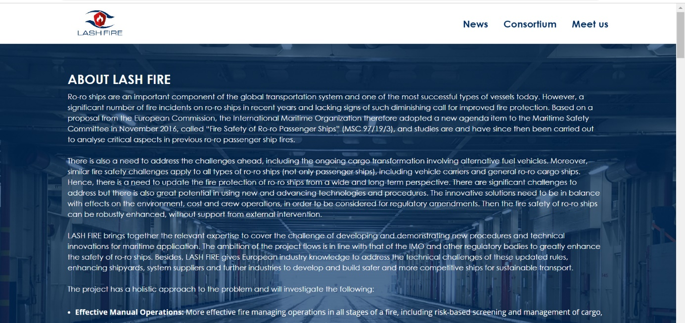
Figure 1 – Home

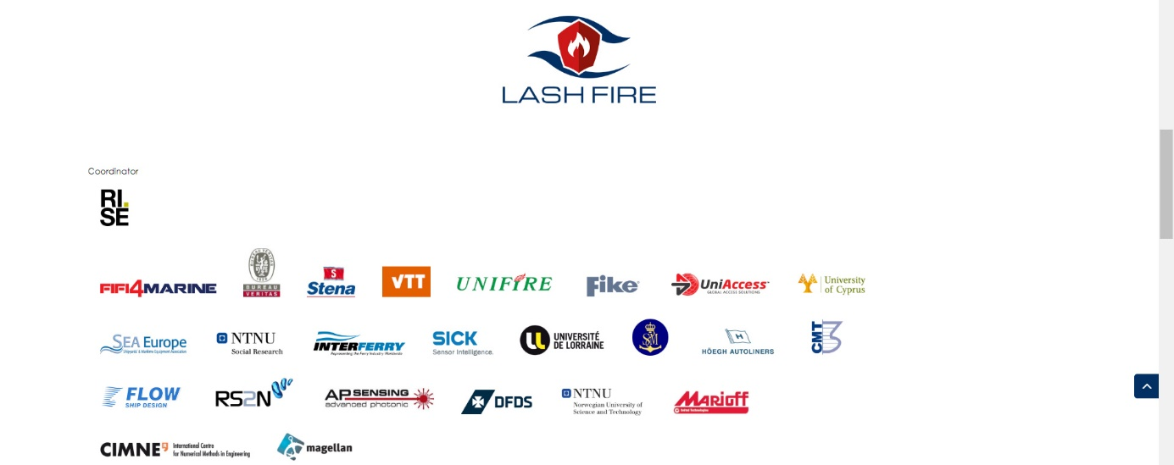
Figure 2 - Consortium
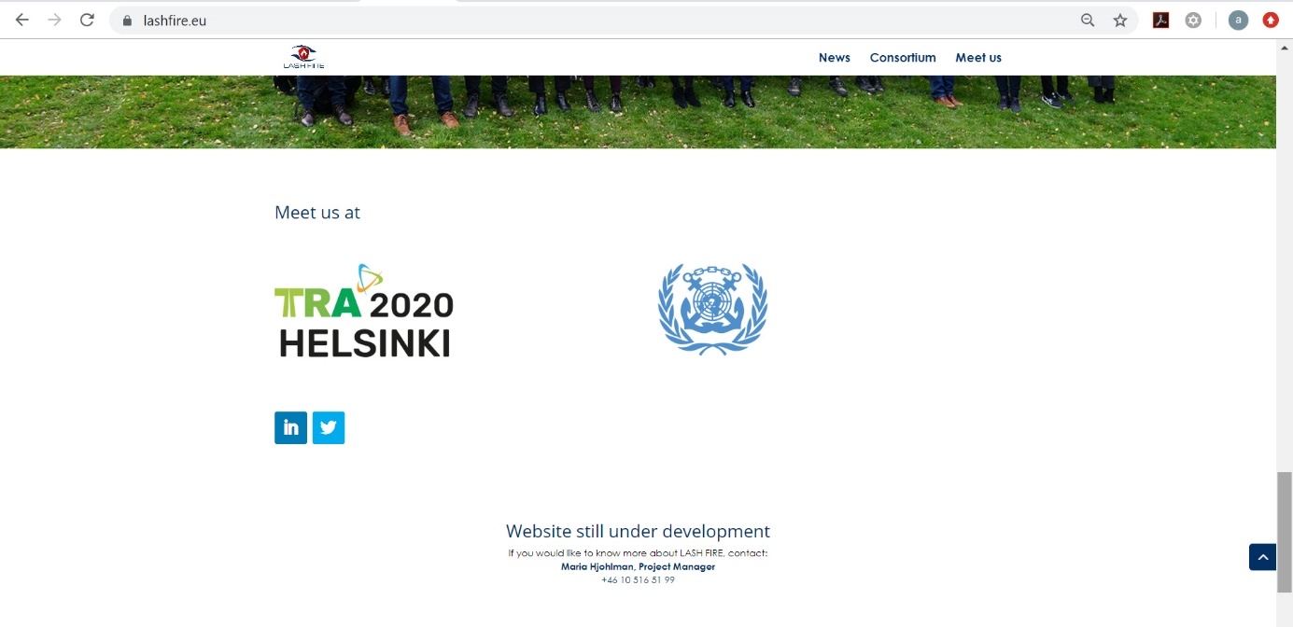
Figure 3 – Meet us

LASHFIRE 2.0
In what can be considered a final draft, the current version 2.0 of the LASH FIRE website contains much more information than before, including several subpages and graphical improvements overall. The website also includes integration of the social media channels of LASH FIRE (Twitter, LinkedIn), enabling improved dissemination. The idea for “LASHFIRE 2.0” was to enable the rest of the members of work package 3 to get an insight of what was possible while giving the chance for feedback and minor improvements.
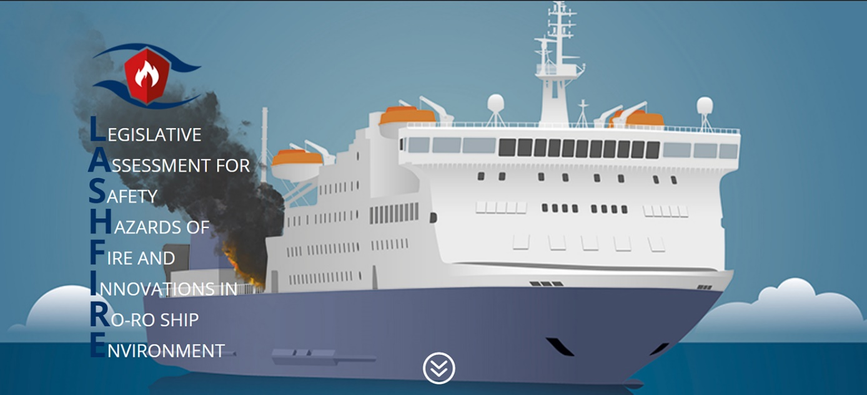
Figure 4 – LASH FIRE 2.0 home

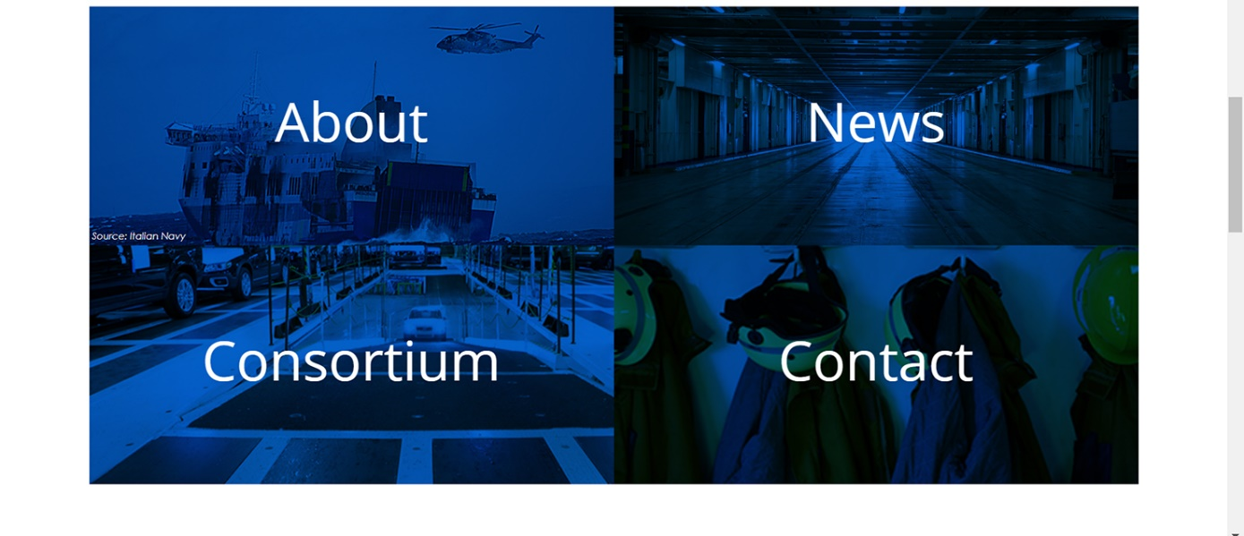
Figure 5 – LASH FIRE 2.0 home menu

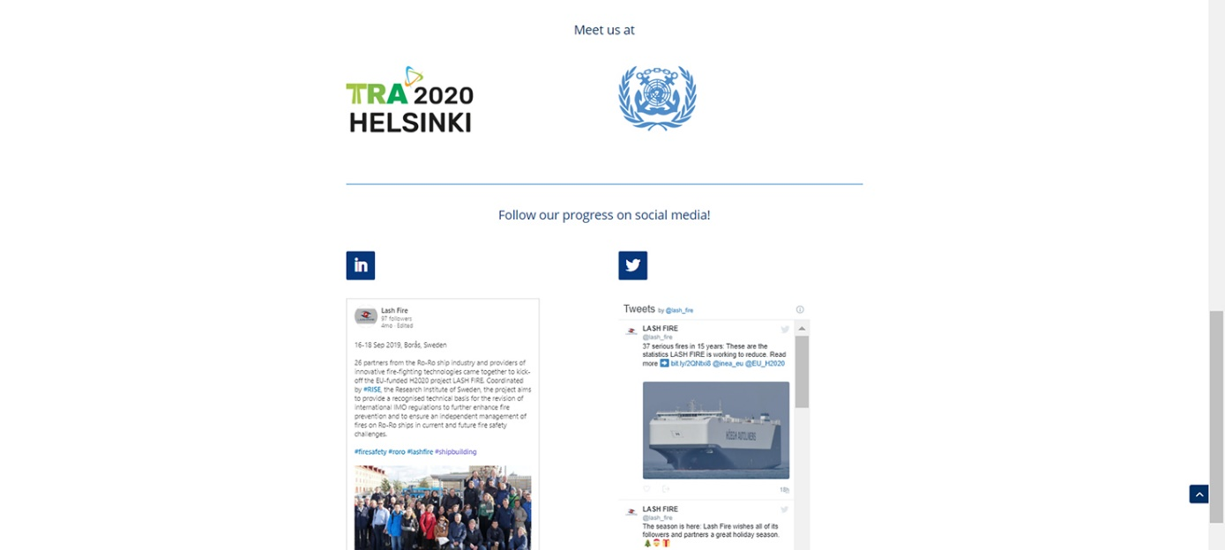
Figure 6 – LASH FIRE 2.0 events and media

Conclusion
Main author of the chapter: Alexander Hertzberg, RISE
The project website introduced in D03.1 is a great way of summarizing the LASH FIRE project in its current state. It includes information of the fundamental parts of LASH FIRE which can easily be shared with specific stakeholders or the general public. The project website is also a communication channel which can be used to strengthen dissemination efforts while offering important information regarding coming events and activities within the project, as well as previous dissemination efforts in the form of press releases etc.
The next step is to use the website for directed dissemination activities, which means adding content and highlighting the possibilities to learn about LASH FIRE by visiting the project website. Even though a final version of lashfire.eu needs to be developed, the current version enables a clear path for dissemination while making sure the latest information can be found online, no matter which device is used by the site visitor.

Indexes

Index of figures
Figure 1: LASH FIRE 1.0 Home ……………………………………………………………………………………………………….…8
Figure 2: LASH FIRE 1.0 Consortium …………………………………………………………………………………………………8
Figure 3: LASH FIRE 1.0 Meet us……………………………………………………………………………………………………….9
Figure 4: LASH FIRE 2.0 home…………………………………………………………………………………………………………..10
Figure 5: LASH FIRE 2.0 home menu ………………………………………………………………………………………………..11
Figure 6: LF 2.0 events and media……………………………………………………………………………………………………11

